- Alarm: ID 02: Front PLS Alarm
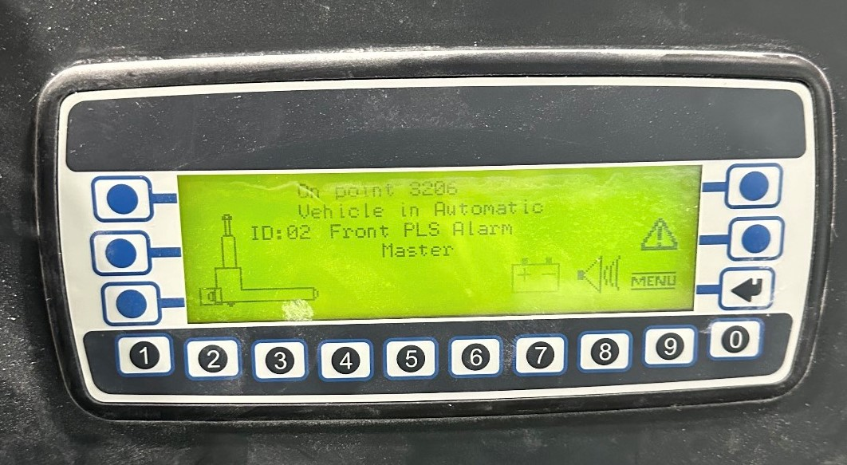
How To Fix:
Remove debris or any unwanted objects from the safety barrier of the front PLS Sick Eye.
The safety barrier has a range of 0-18 inches. Any object within this range will trigger the sick eye.

